Annex VI

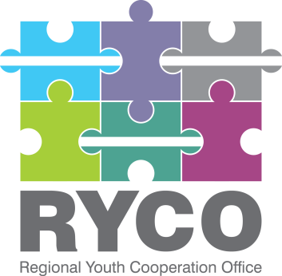
Regional Youth Cooperation Office

Call for Project Proposals 2018
“A Better Region Starts with Youth”

Narrative Report Template

- Use the project proposal as the basis for your narrative reporting
- This report must be completed and signed by the Applicant’s Legal Representative.
- The information provided below must correspond to the financial information that appears in the financial report.
- Please fill out the report electronically.
- Please expand the paragraphs if necessary.
- Please refer to your Grant Contract and send the report to the address mentioned.
- RYCO will reject any incomplete or poorly completed reports.
- The answers to all questions must cover the ENTIRE project implementation period.
- Please make sure that the total number of pages does not exceed 10 pages. Additional annexes such as specific reports, brochure, pictures etc. can be sent in addition to the narrative report.

PART 1. GENERAL INFORMATION

Contract No.
Project title
Priority Area/LOT
Applicant
Legal status  Tick the box by clicking on it. | ☐ Civil Society Organisation  ☐ Public Institution (School)  ☐ Private School  ☐ Other, please specify: ________________
Partner(s) | Partner 1:
 | Partner 2:
 | Partner 3:
 | Partner 4:
 | Partner 5:
Location(s) of the project
Implementation period:
Project starting – ending date
Date of submission of the report | Click here to enter a date.
Name and Surname of the Applicant’s legal representative
Legal Representative Signature

PART 2. GENERAL ACHIEVEMENTS DURING IMPLEMENTATION PERIOD

2.1. Implementation of activities (quantitative)

Activity  (as per Annex I) | Results | Challenges  (if any) | Additional comments
Add rows if needed

2.2. Impact of the project (qualitative): which key results have you achieved through your project regarding regional youth cooperation and reconciliation (in view of what you intended to achieve, as described in your application)?

2.3. What has your project not achieved and why?

2.4. How do you know? (Please describe how progress, changes, results have been monitored and measured in the course of project implementation)

2.5. What would you do differently if you had the chance to start all over again?

2.6. How did you cooperate with your partners during the implementation of your project? What would you do differently next time?

2.7. How did you promote your project during implementation, and what was successful/less successful regarding visibility?

2.8. What kind of follow-up activities are you planning to ensure the sustainability of the project outcomes?

2.9. Have you achieved any additional or unexpected results during the implementation of this project?

PART 3. COOPERATION WITH RYCO

3.1. How would you describe the cooperation and communication with RYCO during the implementation of your project?

3.2. What could RYCO do better?

3.3. Are there any other issues to be brought to RYCO’s attention?

PART 4. STATISTICAL DATA

Please fill out the table:

Total number of participants in the project:
Total number of participants per WB 6 Contracting Party: | For example:  Montenegro: 20 participants  Albania: 10 participants
Total number of participants outside WB6 (if any): | For example:  Germany: 3 participants
Number of participants by gender: | Total number of female participants:
 | Total number of male participants:
Number of participants by age: | Total number of participants age 15 - 18:
 | Total number of participants age 19 - 25:
 | Total number of participants age 26 - 30:
 | Total number of participants over the age of 30:
Type of target groups present within your participants and their number: | For example:  Youth with disabilities: 5 participants  Roma youth: 2 participants

List all the activities defined in the Annex I: Application Form

