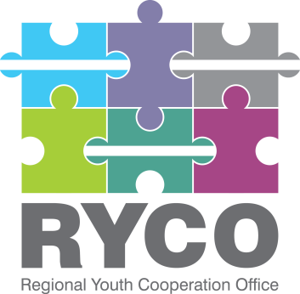
Regional Youth Cooperation Office

Call for Project Proposals 2019
“A Better Region Starts with Youth”

Narrative Report Template

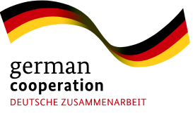

This Open Call is supported by the Federal Republic of Germany
This Narrative Reporting Template is subject to change and, at this stage, serves to inform potential applicants on the reporting requirements and form. The final version of the Narrative Reporting Form that the grantees will use to report on their projects will be provided to them as part of the grant agreement in the contracting phase.

- Use the project proposal as the basis for your narrative reporting
- This report must be completed and signed by the Applicant’s Legal Representative.
- The information provided below must correspond to the financial information that appears in the financial report.
- Please fill out the report electronically.
- Please expand the paragraphs if necessary.
- Please refer to your Grant Contract and send the report to the address mentioned.
- RYCO will reject any incomplete or poorly completed reports.
- The answers to all questions must cover the ENTIRE project implementation period.
- Please make sure that the total number of pages does not exceed 10 pages. Additional annexes such as specific reports, brochure, pictures etc. can be sent in addition to the narrative report.

PART 1. GENERAL INFORMATION

Contract No.
Project title
Priority Area/LOT
Applicant
Legal status  Tick the box by clicking on it. | ☐ Civil Society Organisation  ☐ Public Institution (School)  ☐ Private School  ☐ Other, please specify: ________________
Partner(s) | Partner 1:
 | Partner 2:
 | Partner 3:
 | Partner 4:
 | Partner 5:
Location(s) of the project
Implementation period:
Project starting – ending date
Date of submission of the report | Click here to enter a date.
Name and Surname of the Applicant’s legal representative
Legal Representative Signature

PART 2. GENERAL ACHIEVEMENTS DURING IMPLEMENTATION PERIOD

2.1. Impact of the project (qualitative)
What do you consider to be the key results of your project, regarding its contribution to regional youth cooperation and reconciliation? What impact or change did you observe that your activities made on project participants and others involved? Is this what you intended to happen when you planned the project?

2.2. Implementation of activities (quantitative)
In the table below add all activities listed in your application form, write their main measurable results, describe any challenges you may have experienced during the project implementation and how you responded to them. There is also space for additional comments if you wish to emphasize or clarify anything.

Activity | Results | Challenges  (if any) | Additional comments
Add rows if needed

2.3. (Every project is a learning process for those who implement it as well as for us who support it.) Is there anything you wished to achieve but did not succeed in doing or anything in the course of implementation that did not go as initially planned? Please explain why.

2.4. Please describe how you measured and monitored progress, changes, and results in the course of project implementation. How did you ensure that activities were going as planned and that their results were consistent with what you intended to achieve?

2.5. What lessons did you draw out of the implementation of this project? What would you do differently if you had the chance to start over again?

2.6. Please describe how you ensured cooperation and coordination among the partners during the implementation of this project. What would you do differently next time?

2.7. How did you communicate the project to external audiences? How did you inform your communities on the implementation of the project and its results? How did you ensure visibility of RYCO’s support to your project?

2.8. What are you planning to do to ensure the sustainability of the project outcomes?
2.9. Have you achieved any additional or unexpected results during the implementation of this project?

2.10. Please describe how you ensured diversity within the group of project participants? What did you achieve when it comes to the inclusion of marginalised youth?

2.11. How did you collect feedback from the project participants? What are the results of project evaluation by participants? What did they particularly like? What were they dissatisfied with?

2.12. For the purpose of external communication and promotion of your project results, please share several statements or quotes from either the project participants or project organizers. These should inform about a learning from this project, a change or impact that the project had on participants or organizers.

PART 3. COOPERATION WITH RYCO

3.1. How would you describe the cooperation and communication with RYCO during the implementation of your project? Did RYCO enable you to conduct your activities as planned or were there issues in communication with RYCO that caused any problems to you during implementation?

3.2. What could RYCO do better? What could RYCO do to provide better or more meaningful support to organizations during project implementation? Is there anything RYCO should do differently?

3.3. Are there any other issues to be brought to RYCO’s attention?

PART 4. STATISTICAL DATA

Please fill out the table:

Total number of participants in the project:
Total number of participants per WB 6 Contracting Party: | For example:  Montenegro: 20 participants  Albania: 10 participants
Total number of participants outside WB6 (if any): | For example:  Germany: 3 participants
Number of participants by gender: | Total number of female participants:
 | Total number of male participants:
Number of participants by age: | Total number of participants age 15 - 18:
 | Total number of participants age 19 - 25:
 | Total number of participants age 26 - 30:
 | Total number of participants over the age of 30:
Type of target groups present within your participants and how many of each group:¹ | For example:  Youth with disabilities: 5 participants  Roma youth: 2 participants

List all the activities defined in the Application Form

