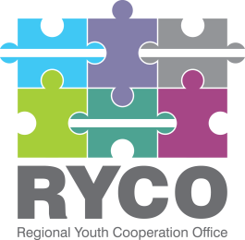

ADDITIONAL INFORMATION

“Implementing partner for delivery of local activities in Montenegro”

Having regard to Section 5 of the “Instructions to tenderer”, part of the published tender dossier in the frame of “Implementing partner for delivery of local activities in Montenegro” call, in response to the queries submitted please find below the additional information provided:

- In relation to the deliverable required in the Terms of Reference, “Key outputs, indicative timelines and budget” section, specifically: “Programmatic and administrative support for the implementation of best ideas- mini grants” and the question submitted, specifically: - Would this support be provided for the users of the mini grant by implementing two national workshops (mentioned in the Background of the Terms of Reference), or directly to the RYCO office?

Please be informed that:

- Local workshops were implemented in December 2020 and they served as space where participants brainstormed and received guidance for the development of the best ideas. Applications for best ideas were received in January and are approved for implementation. As outlined in the TOR, the selected provider should provide both programmatic and administrative support for the implementation of the ideas. The support will be provided to the implementers of the mini-grant, following guidance provided by RYCO office.

- With regard to the following questions:
- Are the mini grants awarded in Montenegro?
- Which organizations are the beneficiaries?
- RYCO is going to provide grants, and a tender is expected to provide administrative and technical support (deliverables + supporting documentation)?.
Please be informed that:
- The mini-grants are awarded in Montenegro. They have already been selected after the local workshops implemented in December.

- Recipients of the mini-grants are young people themselves, but they will not be given the funds directly. The selected service provider will pay directly for the expenses incurred during mini-grants implementations.
- RYCO is selecting a service provider that will provide programmatic support to the mini-grants implementation, administrative support (expenses coverage, reporting, and other admin support if needed). The selected service provider will also organize and implement a national best practices campaign, which will be agreed on jointly with RYCO.

Thank you!

