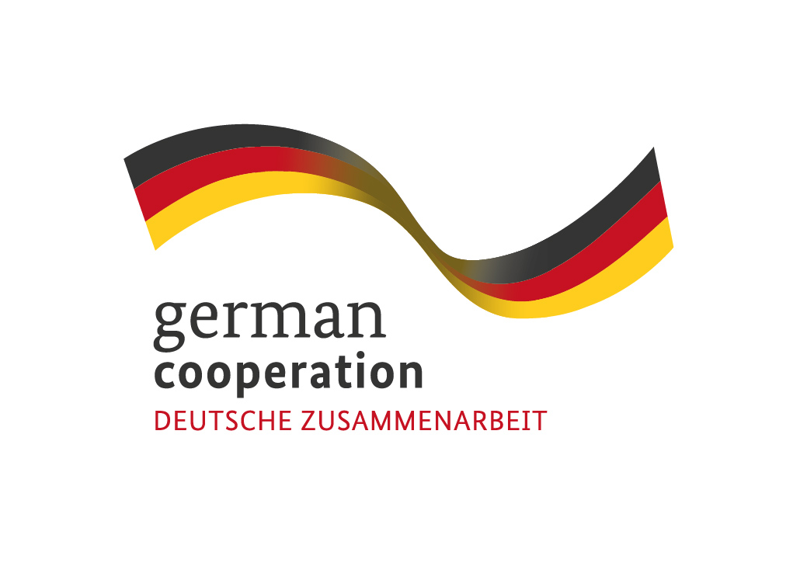

Tirana, 30/07/2021

**CALL FOR APPLICATIONS**

**“Systemic Conflict Analysis expert to support the development of the new RYCO Strategy 2022 -2024”**

This is a call for applications for the above mentioned service contract. Please find enclosed to this invitation the relevant Terms of Reference.

We look forward to receiving your application, which has to be sent no later than the submission deadline at the e mail address specified in the Terms of Reference.

By submitting your application, you accept the terms and conditions set in the Terms of Reference as well as to receive notification of the outcome of the procedure by electronic means. Such notification shall be deemed to have been received by you on the date upon which the contracting authority sends it to the electronic address you referred to in your offer.

Thank you!

**TERMS OF REFERENCE**

**Systemic Conflict Analysis expert to support the development of the new RYCO Strategy 2022 -2024**

**Position:** Systemic Conflict Analysis (SCA) expert to support the development of the new RYCO Strategy 2022 - 2024

**Main Beneficiary:** Regional Youth Cooperation Office (RYCO)

**Financing institution:** German Ministry of Foreign Affairs (GMFA)

**Duration:** Aug 15 - 15 November 2021 - 15 Working days

**Location:** WB6

**Status:** Individual

**Maximum budget available:** 2,500.00 EUR.

**Background / About RYCO**

RYCO is an intergovernmental organization that stewards and promotes regional, cross-border and intercultural cooperation within and among its six Western Balkan Contracting Parties: Albania, Bosnia and Herzegovina, Kosovo*, Montenegro, North Macedonia and Serbia. RYCO’s program focuses on creating opportunities for young people to engage in activities that build mutual understanding and reconciliation in the civic, social, educational, cultural, and sports domains. RYCO initiates and participates in policy making and advocates for reform. It supports the development of a political and social environment that empowers and facilitates youth exchange. A key instrument enabling RYCO to fulfill its mission is grant-making; developing tailored calls for proposals that enable CSOs and schools to engage in initiatives that contribute to mutual understanding of youth from various communities across RYCO’s Contracting Parties, thus contributing to reconciliation and youth participation.

With the support of GMFA, RYCO is starting the development of the new official Strategy of RYCO for the period 2022-2024. This strategy will be developed through an inclusive, interactive and WB6 youth need - based process, built on produced outcomes coming from the 2019-2021 strategy and aligned with RYCO's mission and vision.

*This designation is without prejudice to positions on status, and is in line with UNSCR 1244 and the ICJ Opinion on the Kosovo Declaration of Independence

**Purpose of the service**

RYCO is at the end of the implementation of its current strategy for the period of 2019 - 2021. An evaluation of this strategy is undergoing and now RYCO is starting with the development of the new strategy 2022 - 2024. The development of the new strategy is a process that foresees a large number of consultations and data collection processes throughout the Western Balkan 6 region, both at the regional and national level with the aim of making sure that the input of youth and their needs are incorporated and reflected in this strategy.

The overall purpose of the service is to conduct a regional WB6, systemic conflict analysis (SCA). The SCA will include box analysis, balancing/reinforcing feedback loops, and stakeholders’ description as methodological tools. It will identify key driving factors for conflict and prioritise entry points for future program activities, followed by an extensive list of recommendations.

**Scope of work**

The Expert will work in concert with the other SCA expert hired by the Polish Fund to develop the methodology, guidelines and a set of questions to be used by RYCO facilitators in their field research (interviews, focus group discussions, etc.). In addition, the SCA expert will provide training for the facilitators. The field research will include a set of semi-structured Key Informant Interviews (KIIs) with the relevant representatives of: (i) local authorities; (ii) local NGOs; (iii) the international community, including international donor organizations; (iv) leading researchers/analysts from the Region; (iv) the media; (v) young people (an exact list will be developed in close coordination with RYCO team. All interviews and focus group discussions will be conducted according to the highest ethical research standards.

The entire process will last approximately three months, including the strategic planning process. It will require 15 working days which will be spread during the period of this assignment. These working days will include: (i) training the facilitators on how to conduct SCA; (ii) mentoring the process of SCA drafting; (iii) reviewing the first drafts of SCA reports; (iv) organizing validation workshops with RYCO’s staff; (v) working on and reviewing the final drafts of the SCA; (vI) organizing workshops on summarizing the joint conclusions/ recommendations relevant for RYCO the entire region.

**Expected deliverables, timeline and remuneration**

|  |  |  |  |
| --- | --- | --- | --- |
| **Deliverable** | | **Timeline[1]** | **Remuneration** |
| 1 | Desk review and/or analysis of relevant docs | Aug 15 - Aug 20 | First installment of 50%. |
| 2 | Peer review of SCA Analysis of RYCO consultations | Aug 01 - Aug 25 |
| 3 | Analysis of collected material and drafting regional SCA report | Sept. 20- Oct 08th |
| 4 | Preparation of Working materials for final Validation Workshop | 20 - 28 Sept |
| 5 | Validation workshop, Facilitation of Workshop and reporting | 29th of Sept | Second installment of 50%. |
| 6 | Preparing draft recommendations | 01- 15 Oct |
| 7 | Participating in the Strategy Forum to discuss the first draft of the strategy | 13 - 15 Oct |
| 8 | Taking part in the final work of the Program task force. | 20 Oct- 10 Nov |  |

Deliverables from 1-4 will be conducted in concert with the Systemic Conflict Analysis Expert hired under the polish fund. While the rest of deliverables will be managed solely by the expert hired under this contract.

The Contract will be realized in Euro and the payment will be conducted in two installments, after successful completion of service and provided deliverables are approved. The maximum budget available is 2,500.00 EUR. For payment, the provider will be requested to submit the approved deliverables and reports which should be in English, and invoices (signed originals).

**The methodology and approach**

The development of the SCA will depend on qualitative preparations and training of external facilitators, therefore the above mentioned deliverables will have to be planned well.

1. Desk review and/or analysis of relevant docs. RYCO project staff will provide the SCA expert with relevant background documents for their review, this list should not be seen as exhaustive therefore the expert should also analyses any other document that s/he finds it important for the assessment.
2. Development of the SCA methodology, the expert is foreseen to develop guidelines for interviews and focus groups, including a list of questions needed to drive the interviews fwd.
3. Training of external facilitators will be planned and implemented, including the agenda of the training. In addition to the training the SCA expert will support facilitators through mentoring them and answering their questions and uncertainties.
4. Once the facilitators have collected all materials an analysis of collected material will be conducted. This will precede drafting of the regional SCA report from the experts.
5. Once the SCA report is conducted an validation workshop will be organised.
6. The last activity of the expert will be to participate in the Strategy Forum where will contribute in discussing the first draft of the strategy.

**Required Skills, Experience and Qualifications**

The Content Expert should fulfill the following requirements:

* Master degree in Social Studies, International Development, Development Economics/Planning, Economics, or any other relevant university degree;
* Previous experience with Systemic Conflict Analysis (SCA) methodology and conducting SCA in at least 2 CPs;
* At least 3 years’ experience of developing strategic planning process and/or development of strategic documents for international/regional organizations;
* Previous experience working at the regional level, and good knowledge of the WB6 region, its history and social context;
* Advanced computer skills and knowledge using MS office, Google Drive and other Google services (docs, spreadsheets, etc);
* Excellent writing and verbal communication skills;
* Excellent oral and written proficiency in English required. Knowledge of at least one other official language of the Western Balkan region is required.
* Resident of one of WB6 CPs;
* Ability to work in a multicultural environment and to display cultural, gender, nationality and religious sensitivity, and adaptability;

**Evidences and supporting documents:**

The application should contain:

* CV (Europass CV format);
* SCA Concept proposal
* Financial offer
* Scanned passport copy.

**Application process**

Interested applicants are advised to carefully study all sections of this ToR, and ensure that they meet the general requirements as well as specific qualifications described. Incomplete applications will not be considered for further evaluation. Please make sure you have provided all requested evidences and supporting documents. Interested applicants should develop and submit their application in English exclusively to the contracting authority: **Regional Youth Cooperation Office (RYCO)** and be sent to the following email address:

[procurement@rycowb.org](mailto:procurement@rycowb.org)

**Deadline for receipt of applications**: 06/08/2021, 17h00.

**Award criterion:** The evaluation of applications will be based on the best price-quality ratio among compliant applications. Therefore, the components that will be scored the most will be the experience of the expert and professional qualifications. The balance between price and technical offer will be 80% on technical and 20% on financial.

1. This timeline may be a subject to change upon the overall project timelines, challenges and delays.