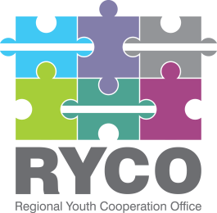

November 3rd,2021

ADDITIONAL INFORMATION

Contract title: “Supply and production of branded visibility materials for Regional Youth Cooperation Office (RYCO)”

Having regard to Section 5 of the “Instructions to tenderer”, part of the published tender dossier in the frame of the “Supply and production of branded visibility materials for Regional Youth Cooperation Office (RYCO)” call, in response to an inquiry submitted please find below the additional information provided:

Question 1 | Can you please specify the articles that must have the logo or logos, what measure the logos should be because depending on this it can be  determined the price?
Answer 1 | Each of the items listed in the Tender Dossier will contain a logo and/or other visual elements. Please refer to the maximum available printing sizes of each of the items based on the type of items you are offering.
Question 2 | Calendar: related to the pictures that will be used on the calendar, will these pictures be defined from your part or from the contractor's  part?
Answer 2 | RYCO will provide the awarded tenderer designs for each of the items listed in the Tender Dossier.
Question 3 | Mug: What measures should the mug be keeping in mind that the mugs could be medium or big measure?
Answer 3 | Mugs should be of the average size: 300-350ml
Question 4 | Umbrella: What do you mean with the measures (aap. 20 x 7 cm)? Is this related to the square measure of the umbrella or something else?
Answer 4 | The measures specified are referring to the printing size.
Question 5 | Roll ups: What do you mean with the measures 80x100cm? As a matter of fact the measures of roll ups are: 80x200cm or 90x200cm  or 100x200cm.
Answer 5 | This is a typo. The measures should be 80x200cm.
Question 6 | Stickers: Do you need the Adhesive letter or the plastic one which is against the water?
Answer 6 | We are looking for adhesive paper.

Thank you!

