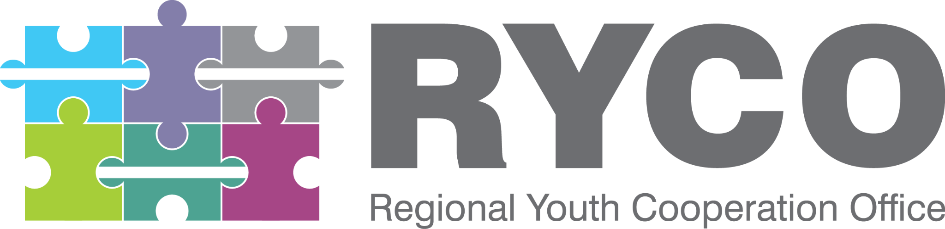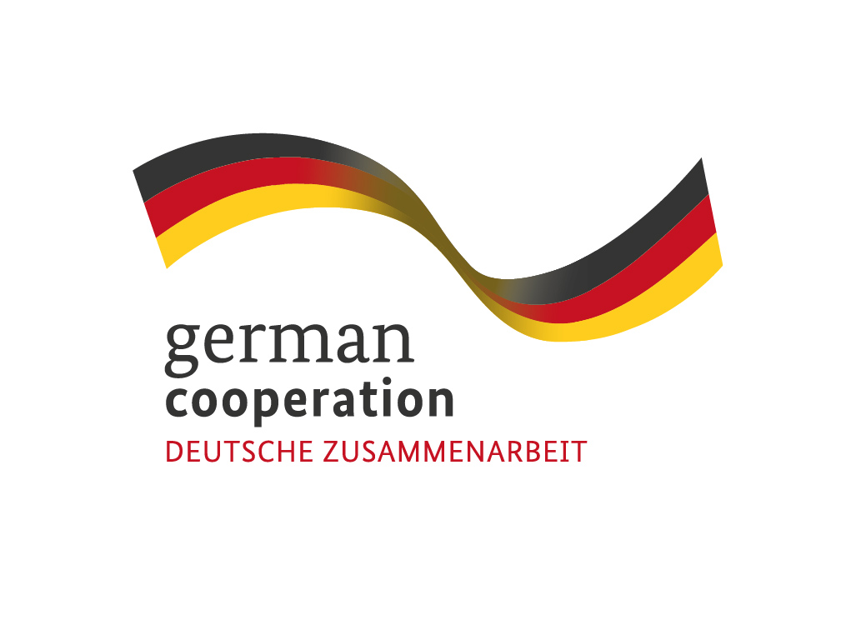

Tirana, 27/10/2021

CALL FOR APPLICATIONS

“External Expert to support facilitation of the final stage of development of the RYCO Strategy 2022 – 2024”

This is a call for applications for the above mentioned service contract. Please find enclosed to this invitation the relevant Terms of Reference.

We look forward to receiving your application, which has to be sent no later than the submission deadline at the e mail address specified in the Terms of Reference.

By submitting your application, you accept the terms and conditions set in the Terms of Reference as well as to receive notification of the outcome of the procedure by electronic means. Such notification shall be deemed to have been received by you on the date upon which the contracting authority sends it to the electronic address you referred to in your offer.

Thank you!

TERMS OF REFERENCE

Position: External Expert to support facilitation of the final stage of development of the RYCO Strategy 2022 - 2024
Main Beneficiary: Regional Youth Cooperation Office (RYCO)
Financing institution: German Ministry of Foreign Affairs (GMFA)
Duration: 15 days
Workbase: Online/Field work
Maximum budget available: 2 500 Euro

Background / About RYCO
RYCO is an intergovernmental organization that stewards and promotes regional, cross-border and intercultural cooperation within and among its six Western Balkan Contracting Parties: Albania, Bosnia and Herzegovina, Kosovo, Montenegro, North Macedonia and Serbia. RYCO’s program focuses on creating opportunities for young people to engage in activities that build mutual understanding and reconciliation in the civic, social, educational, cultural, and sports domains. RYCO initiates and participates in policy making and advocates for reform. It supports the development of a political and social environment that empowers and facilitates youth exchange. A key instrument enabling RYCO to fulfill its mission is grant-making; developing tailored calls for proposals that enable CSOs and schools to engage in initiatives that contribute to mutual understanding of youth from various communities across RYCO’s Contracting Parties, thus contributing to reconciliation and youth participation.
With the support of GMFA, RYCO is starting the development of the new official Strategy of RYCO for the period 2022-2024. This strategy will be developed through an inclusive, interactive and WB6 youth need - based process, built on produced outcomes coming from the 2019-2021 strategy and aligned with RYCO's mission and vision.

Purpose of the facilitation:
RYCO is at the end of the implementation of its current strategy for the period of 2019 - 2021. An evaluation of this strategy is undergoing and now RYCO is starting with the development of the new strategy 2022 - 2024. The development of the new strategy is a process that foresees a significant number of consultations and data collection processes throughout the Western Balkan 6 region, both at the regional and local level with the aim of making sure that the input of youth and their needs are incorporated and reflected in this strategy.
The overall purpose of the facilitation is to help the implementation team at RYCO to organize different activities the outputs of which will contribute to and feed the development of the new RYCO strategy for the period of 2022 - 2024.
Scope of work:
The expert will be part of a RYCO Program Task Force run by Director of Programs. The general scope of work of the expert is to contribute and support final stage of strategy development process, more specifically: Regional Strategic Forum, analysis of collected data and findings from previous consultative process and desk review, support of preparation of the methodology for Final Design Workshop and co-facilitation of the workshop and providing inputs for Theory of Change and Strategy.
Expected deliverables, timeline, and remuneration:
Deliverable |  | Timeline | Working days
1 | Taking part in the preparation of Regional Strategic Forum and providing inputs for working part. | Beginning of November | 1 day
2 | Taking part in the Regional Strategic Forum in Serbia. | 7-10 November | 4 days
3 | Contributing with proposals for methodology of the Final Design Workshop. | 12  November | 1 day
4 | Taking part in the Final Design Workshop and supporting with facilitation of one part of the program. | 19-22 November | 4 days
5 | Developing Theory of Change and providing inputs for the new Strategy, based on the conclusions of Final Design Workshop, Program Task Force and RYCO leadership. | 22-24 November | 2 days
6 | Final Review Report with recommendations for development of programmatic/projects ideas based on the new Strategy and taking part in brainstorm session online or in Tirana. | Until 15 December | 3 days

The Contract will be realized in Euro and the payment will be conducted in two installments. The first installment of 50% will be reimbursed upon successful completion Tasks 1, 2 and 3. While the second and the last installment will be done after successful completion of service and provided deliverables are approved.
The maximum budget available is 2 500 EUR. For payment, the provider will be requested to submit the approved deliverables and reports which should be in English, and invoices (signed originals). Additionally, all the travel and accommodation costs (if they occur) occurring due to the completion of the service will be covered by RYCO. The above mentioned timeline may be subject to change upon the overall project timelines, challenges and delays.
Required Skills, Experience and Qualifications:
The external expert should fulfill the following requirements:
- University degree in Social Studies, International Development, Development Economics/Planning, Economics, or any other university degree;
- At least 7 years’ experience of facilitating and/or moderating consultation processes or strategic planning process and development of strategic documents in your area;
- At least 7 years’ experience in social development projects and project management in the Western Balkans;
- At least 5 years of experience in the field of youth, youth work and/or peacebuilding in the region;
- Previous experience working at the regional level, and good knowledge of the WB6 region, its history, and social context, civil society and political systems.
- Advanced computer skills and knowledge using MS office, Google Drive and other Google services (docs, spreadsheets, etc);
- Excellent writing and verbal communication skills;
- Good strategic and analytical thinking and ability to interpret data from different sources;
- Excellent oral and written proficiency in English required. Knowledge of at least one other official language of the Western Balkan region is required.
- Resident of WB6.

Evidences and supporting documents:
The application should contain:
- CV (Europass CV format);
- Financial offer
- Scanned passport copy.

Application process:

Interested applicants are advised to carefully study all sections of this ToR, and ensure that they meet the general requirements as well as specific qualifications described. Incomplete applications will not be considered for further evaluation. Please make sure you have provided all requested evidences and supporting documents. Interested applicants should develop and submit their application in English exclusively to the contracting authority: Regional Youth Cooperation Office (RYCO) and be sent to the following email address:
procurement@rycowb.org

Deadline for receipt of applications: 04/11/2021, 17h00.

Selection process and award criterion:
The successful applicant will be selected based on the best price-quality ratio among compliant applications. Therefore, the components that will be scored the most will be the experience of the expert and professional qualifications. The balance between price and technical offer will be 90% on technical and 10% on financial.

This designation is without prejudice to positions on status, and is in line with UNSCR 1244 and the ICJ Opinion on the Kosovo Declaration of Independence
This timeline may be subject to change upon the overall project timelines, challenges and delays.

