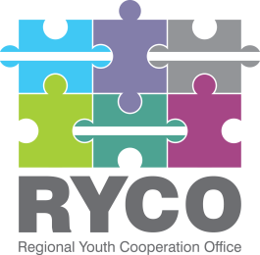

November 16th,2021

ADDITIONAL INFORMATION

Contract title: “Application of existing and designed logo, supply and production of branded visibility materials”

Having regard to Section 5 of the “Instructions to tenderer”, part of the published tender dossier in the frame of the “Application of existing and designed logo, supply and production of branded visibility materials” call, in response to inquiries submitted please find below the additional information provided:

Question 1 | if Our agency located in Mostar, Bosnia and Herzegovina wins the tender, will we have to deliver the materials to Sarajevo?
Answer 1 | Indeed, as foreseen in Section 4 "Required services" of the Terms of Reference, part D of the Tender Dossier specifically: "Delivery of visibility materials to RYCO premises and/or GIZ premises on the territory of the selected service provider", if the winning tenderer is from Bosnia and Herzegovina it should deliver the items in RYCO premises and/or GIZ premises in Sarajevo.
Question 2 | Can you please specify how many sheets does this notebook need to contain
Answer 2 | No of pages: 100-160

Thank you!

