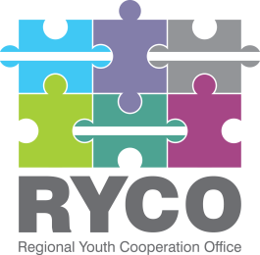

December 21st ,2021

CORRECTIONS

Contract title: “External Audit of SIDA project “Institutional Capacity Building support to RYCO”

Having regard to Section 5 of the “Instructions to tenderer”, part of the published tender dossier in the frame of the “External Audit of SIDA project “Institutional Capacity Building support to RYCO” call, due to some discrepancies noticed in the Tender Dossier please find below for your consideration the relevant corrections:

Correction no: 1 | The maximum budget specified in the Contract Notice, Part A of the Tender Dossier, point 9, Instructions to Tenderer, point 4.2, part B of the Tender Dossier and in the Terms of Reference, Part D of the Tender dossier at the amount of: 3 372 Euro is corrected to the exact value of: 3 500 Euro.
Correction no: 2 | The figures set in the following paragraphs of the Terms of Reference, part D of the Tender Dossier are irrelevant to the contract therefore both paragraphs are removed from the Terms of Reference. Please disregard them:  - The project “Institutional Capacity Building support to RYCO” project is financed by Swedish International Development Cooperation Agency Sweden» with a total maximum budget of 1,853,369 SEK (estimated 168,600.00 EUR), and is implemented by Regional Youth Cooperation Office (RYCO).  - The total maximum estimated expenditures which are the subject of this expenditure verification is 168,600 EUR
Correction no: 3 | The implementation period of the task set in point 15 of the Contract Notice, part A of the Tender Dossier: January 2022 – March 2022 is corrected to: February 2022 – March 2022.  Following, the paragraph set in the Terms of Reference, part D of the Tender Dossier: specifically:  “The audit for “Institutional Capacity Building support to RYCO” project to be conducted within January 2022 and audit report should be submitted within March 2022”. is corrected as follows:  “The audit for “Institutional Capacity Building support to RYCO” project to be conducted within February 2022 and audit report should be submitted within March 2022”.

Thank you!

