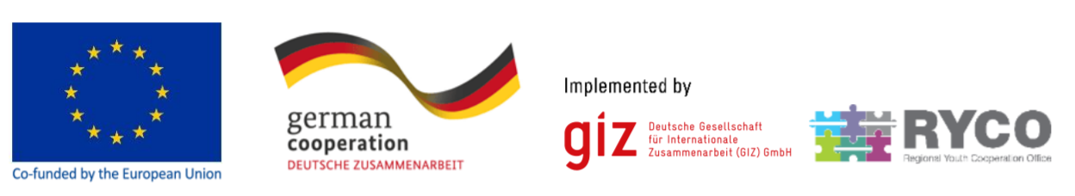

Position: | Local Program Officer
Vacancy ref: | HR056
Work base: | RYCO Local Branch Office, Sarajevo, Bosnia and Herzegovina
Contract duration: | 12 months, with the possibility of extension
Expected start: | February 2022
Project duration: | until Mar-2024
Application deadline: | 14-Jan-2022

About RYCO:

Regional Youth Cooperation Office (RYCO) is an independently functioning institutional mechanism, founded by the Western Balkans 6 participants (WB6): Albania, Bosnia and Herzegovina, Kosovo∗, Montenegro, North Macedonia and Serbia, aiming to promote the spirit of reconciliation and cooperation between the youth in the region through youth exchange programs. The Agreement on the Establishment of RYCO was signed by the WB 6 Prime Ministers at the WB Summit held in Paris, on 4 July 2016. Please click here for more information.

About the project:

RYCO has entered a multi-donor partnership jointly co-financed by the European Union and the German Federal Ministry for Economic Cooperation and Development (BMZ) and implemented by Deutsche Gesellschaft für Internationale Zusammenarbeit (GIZ) GmbH.
The project contributes to the overall objective of increasing skills and knowledge of young people in the Western Balkans by enhancing education systems and promoting cooperation in the region through the specific objective of strengthening capacities of RYCO and establishing a regional school exchange scheme. For more detailed information, please click here.

Job summary:

The Local Program Officer (LPO) will assist the Program Coordinator in RYCO’s Head Office in Tirana and the Head of Local Branch Office in Bosnia and Herzegovina in the implementation of the “School to school exchange project co-financed by the European Union and the German Federal Ministry for Economic Cooperation and Development (BMZ) and implemented by GIZ. In addition, the LPO will assist in the implementation of RYCO programs, projects and administrative activities with a special focus on RYCO’s grants. His/her principal role is to assure the provision of support and assistance to the Project Coordinator and the Head of Local Branch Office in all aspects of project management. The Local Program Officer will report directly to the Head of LBO and Program Coordinator. All duties performed by the Local Program Officer will be in line with RYCO rules and procedures, as well as donor requirements.

Responsibilities:

- Assists in overall project implementation in close consultation and coordination with the Project Coordinator and Head of Local Branch Office;
- In close collaboration with the Head Of Local Branch Office, supports the Project Coordinator in monitoring and evaluating of project activities;
- Communicates and assists the representatives of the supported projects and ensures that activities are in line with the agreed activity plans and timelines;
- Assists the Head of Local Branch Office in implementing program activities of the LBO, in order to meet all the key requirements and goals set by the Strategic Plan and action plans of RYCO;
- Assists the Head of Local Branch Office in preparing annual and periodical reports to the RYCO Head Office for program related work– in line with annual action plans and annual budgets and in accordance with internal rules and procedures;
- Undertakes field visits to evaluate and improve the planning, programming, implementation and monitoring of the project;
- Writes reports and analyses of programmatic activities;
- Oversees administrative and technical tasks in cooperation with HLBO and local FAO;
- Organizes archiving of necessary program documentation;
- Assists the Head of Local Branch Office in planning and implementation of activities in all phases of the RYCO grant schemes in accordance with internal rules and procedures as well as donor rules;
- Supports organization of capacity building of Project and RYCO activities in its Contracting Party;
- Collects general information related to the scope of work of RYCO (reports, publications, researches, strategic documents) and prepares materials as input for the design of RYCO program activities, and contribute to the visibility of RYCO by preparing content for RYCO’s external communication (pictures, videos, written contributions) in coordination with the team members in charge for visibility and project coordination;
- Works in collaboration with other teams including Grants Unit, Finance, and Communications;
- Assists the Head of Local Branch Office in implementing program activities of the Office in the local level, in order to meet all the key requirements and goals set by the Strategic Plan and action plans of RYCO;
- Assists the Head of Local Branch Office in preparing annual and periodical plans and reports to the RYCO Head Office for program – in line with annual action plans and annual budgets and in accordance with internal rules and procedures;
- Performs other duties related to RYCO scope of work, as required.

Requirements:

- Bachelor degree with minimum three (3) years of higher education;
- At least three (3) years of demonstrated experience in CSO sector and good understanding of project management;
- Previous experience in youth, intercultural and reconciliation related projects is considered an asset;
- Experience in organizing capacity building programs and activities for youth, schools and/or youth organizations.
- Experience and ability to work in intercultural environments;
- Good understanding of youth policy and youth work in Bosnia and Herzegovina and WB6;
- Good understanding of the social/ political context of the Western Balkan region;
- Strong organizational skills and ability to coordinate various responsibilities and prioritize conflicting demands and deadlines;
- Excellent interpersonal and communication skills;
- Excellent problem-solving ability;
- Highly motivated, responsible, self-directed, resourceful and flexible;
- Proficient command of English;
- Knowledge of Bosnian is required, knowledge of other WB6 languages is an asset;
- Excellent knowledge of MS Office.

How to apply:

To be considered for this position, please send the application materials via email, with the subject line “HR056 LPO BiH” to recruitment@rycowb.org no later than January 14th, 2022. All applications must include:

- Application Form (completed in English language)
- Europass CV format (completed in English language)
- A scanned copy of your academic qualification (in English or local language)
- A scanned passport copy;
- Two written reference letters from previous employers (in English language)

Female candidates are encouraged to apply
Only finalists will be contacted for the next recruitment stage which is a written assignment, followed by the interviews. The successful candidate will be required to submit a criminal record check before being offered a contract with RYCO.

∗ This designation is without prejudice to positions on status, and is in line with UNSCR 1244 and the ICJ Opinion on the Kosovo Declaration of Independence.

