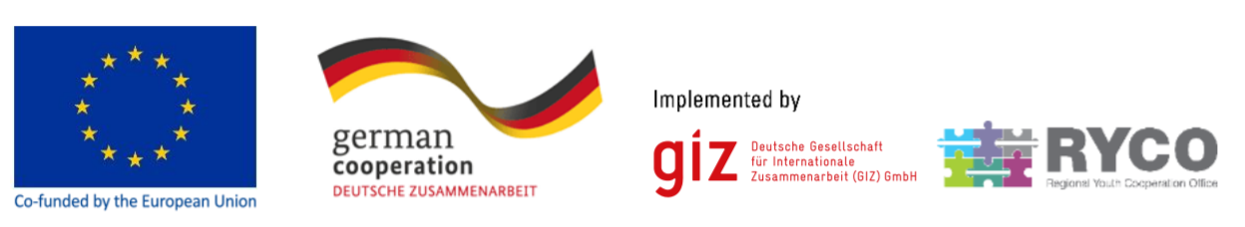

Position: | Digital Platform and Communications Coordinator
Vacancy ref: | HR057
Work base: | RYCO Head Office, Tirana, Albania
Contract duration: | 12 months, with the possibility of extension
Expected start: | February 2022
Project duration: | until Mar-2024
Application deadline: | 14-Jan-2022

About RYCO:

Regional Youth Cooperation Office (RYCO) is an independently functioning institutional mechanism, founded by the Western Balkans 6 participants (WB6): Albania, Bosnia and Herzegovina, Kosovo∗, Montenegro, North Macedonia and Serbia, aiming to promote the spirit of reconciliation and cooperation between the youth in the region through youth exchange programs. The Agreement on the Establishment of RYCO was signed by the WB 6 Prime Ministers at the WB Summit held in Paris, on 4 July 2016. Please click here for more information.

About the project:

RYCO has entered a multi-donor partnership jointly co-financed by the European Union and the German Federal Ministry for Economic Cooperation and Development (BMZ) and implemented by Deutsche Gesellschaft für Internationale Zusammenarbeit (GIZ) GmbH.
The project contributes to the overall objective of increasing skills and knowledge of young people in the Western Balkans by enhancing education systems and promoting cooperation in the region through the specific objective of strengthening capacities of RYCO and establishing a regional school exchange scheme. For more detailed information, please click here.

Job summary:
The Digital Platform and Communications Coordinator is responsible to the Project Leader and will support various communication and visibility activities coordinated by the Communication and Visibility Officer that aim to promote the work of the project implementation. He/she will specifically be in charge of coordinating, networking, implementing and monitoring a communication strategy and associated products and activities on an on-going basis with public audiences, with the objective of promoting awareness, understanding and support of the project Output 2 “Establishment of regional cooperation on youth exchange among RYCO/ Ministries of Education” and Output 3 “Implementation of School Partnership Scheme (SPS)”, and support for RYCO's mission in the regional level. All duties performed by the Digital Platform and Communications Coordinator will be in line with RYCO rules and procedures, as well as donor requirements.
Responsibilities:

- In collaboration with the Project Leader and the Communication and Visibility Officer, prepare the implementation of the projects’ communication plan;
- Coordinates development and daily management of the future digital youth platform of RYCO.
- Produce high-quality project-focused stories that demonstrate RYCO’s impact for engagement on digital channels and public engagement;
- Produce high quality, project-focused visual content (photo and or video) that inspires, engages and positively transforms diverse audiences;
- Initiate relevant topical content in support of the project key priorities and key regional moments for use to engage audiences;
- Maintain calendar of key events/conferences/meetings and work closely with the project team in the WB6 region;
- Support RYCO and the School-to-School project to reach its target audiences and inspire meaningful action;
- Work with the Project Leader and Communication and Visibility Officer, Program Coordinator and six LBOs to prepare for external events and message delivery;
- Ensure distinctive and consistent brand identity across all external outputs;
- Develop and maintain key media contacts and build strategic relationships with media in the WB6 region;
- Proactive media monitoring and support in reputation risk management;
- Facilitate, coordinate and liaise with service providers and contractors to ensure timely and high-quality delivery of results;
- Taking care of regular monitoring reports statistics on media activities and outreach.
- Performs other duties related to RYCO, implementation of RYCO Communication Strategy and project scope of work, as required.

Requirements:

- Nationality of one of the WB 6 Contracting Parties;
- Bachelor degree with minimum three (3) years of higher education in public relations, communications or a related field;
- At least five (5) years of professional experience in the field of communications in a similar role;
- Experience in online platforms, content production, photo and video editing, storytelling, management of social media, media campaigns, public relations and event management.;
- Experience in copywriting and editing, background in research;
- Strong attention to detail;
- Ability to work harmoniously within teams, often while under pressure;
- Excellent communication (oral and written) and presentation skills;
- Experience and ability to work in intercultural environments;
- Good understanding of Western Balkan Six context (social, economic and political environment);
- Previous experience in youth, intercultural and reconciliation related projects will be an asset;
- Time management skills and ability to prioritize work;
- Proficient in MS Office; knowledge of photo and video-editing software (e.g. Photoshop, InDesign);
- Proficient command of English;
- Knowledge of one official WB6 language is a must, while knowledge of other additional languages in the WB6 is an asset.

How to apply:

To be considered for this position, please send the application materials via email, with the subject line “HR057 Digital Platform and Communications Coordinator” to recruitment@rycowb.org no later than January 14th, 2022. All applications must include:

- Application Form (completed in English language)
- Europass CV format (completed in English language)
- A scanned copy of your academic qualification (in English or local language)
- A scanned passport copy;
- Two written reference letters from previous employers (in English language)

Female candidates are encouraged to apply.
Only finalists will be contacted for the next recruitment stage which is a written assignment, followed by the interviews. The successful candidate must submit a criminal record check before being offered a contract with RYCO.

∗ This designation is without prejudice to positions on status, and is in line with UNSCR 1244 and the ICJ Opinion on the Kosovo Declaration of Independence.

