Contracting Authority:
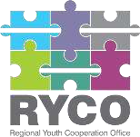
Regional Youth Cooperation Office (RYCO)

Call for Assessors

in the frame of the

Calls for Proposals
“RYConnecting you(th)”

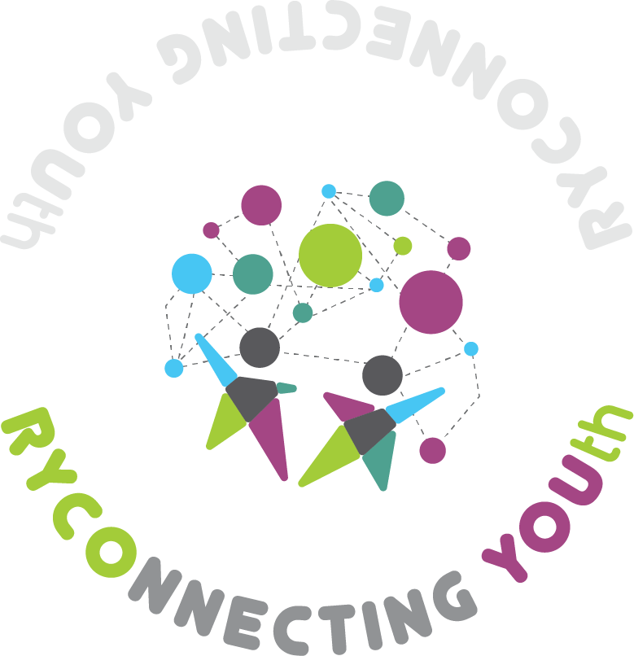

Reference number:

RYCO/CfA/2023

Date of publishing:
18/07/2023
Preface
The Regional Youth Cooperation Office (RYCO) is an intergovernmental organisation that stewards and promotes regional, cross-border and intercultural cooperation within and among its six Western Balkan Contracting Parties – Albania, Bosnia and Herzegovina, Kosovo, Macedonia, Montenegro and Serbia. RYCO’s unique governance system brings together government and civil society representatives to ensure young people are represented at all levels within the organisation. Its Local Branch Offices ensure RYCO is represented in all the six Contracting Parties, while its Head Office is the organisational hub.

RYCO is launching the Call for Assessors to identify and select qualified and experienced professionals to join the RYCO Pool of Assessors set up for project assessment. The Assessors selected within the framework of this Call will be involved in the assessment process for the project applications submitted under the Calls for Proposals “RYCOnnecting you(th)” dedicated to civil society organisations launched on July 7, 2023 and will remain on RYCO’s database for the future Calls for Proposals to be launched in 2024-2025.

The Pool of Assessors created based on this Call will include only the candidates fulfilling the requested minimum requirements and meeting the selection criteria. Only the assessors registered in the Pool of Assessors can take part in the assessment process as external experts. Please note that being registered in the Pool of Assessors does not imply any obligations to award a contract to the successful candidates.

Introduction

RYCO’s programming for 2022-2024 aims to boost the competences of young people, civil society and schools in the region by funding project ideas that connect schools and Civil Society Organisations in the region. It aims to invigorate and enhance constructive dialogue, enable and stimulate intercultural learning and build mutual understanding. Through non-formal education investments, RYCO will strengthen the competences of young people and encourage their active citizenship.

Who is RYCO?
The Regional Youth Cooperation Office (RYCO) is an intergovernmental organisation that stewards and promotes regional, cross-border, and intercultural cooperation within and among its six Western Balkan Contracting Parties (WB6) – Albania, Bosnia and Herzegovina, Kosovo , Montenegro, North Macedonia, and Serbia. RYCO’s unique governance system brings together government and civil society representatives to ensure young people are represented at all levels within the organisation. Its Local Branch Offices ensure RYCO is represented in all the six Contracting Parties , while its Head Office is the organisational hub. RYCO’s Vision Young people are playing a pivotal role in fostering reconciliation and building a culture of understanding and dialogue. They are active contributors to democratic development, social and economic prosperity, and European integration in an increasingly open Western Balkan region. Contracting Parties in the Western Balkans are providing proactive support to youth exchange and youth engagement within the Contracting Parties, and across the region. RYCO believes that building true and enduring reconciliation involves a process that brings together individuals, groups, and societies burdened by past or present conflicts and negative representations and perceptions of “the other”. Through shared experience, cooperation, and ongoing exchange, new pathways can be built to reconcile people who would otherwise remain trapped in the past.

RYCO’s overall programme
Over many years considerable efforts have been invested in the region to support youth exchange. However, until recently, the principal opportunity for mobility and youth exchange focused on young people visiting countries beyond the Western Balkans. While any opportunity for cross-border youth exchange was welcome, young people who could benefit from such exchange programmes were unable to experience the opportunities and challenges of meeting their peers within their region. While their worldview may have been expanded, they returned with their attitudes and behaviours relative to their peers in the region unchallenged and unchanged. It was so much easier to arrange a connection with a stranger outside the Balkans than to face the potentially uncomfortable, but existentially essential need to build a prosperous and peaceful future with one’s immediate neighbours. Young people in the Western Balkans live with the pressures and influences of a social and political narrative that is distorted by prejudice, denial, revisionism, and nationalism. Inherited, negative narratives form the basis for young people’s future life choices about career, residence, friendships, and even the possibility of dialogue with other people; thus, compounding negative narratives about “the other”. In this volatile context, there is a notable lack of opportunity for young people to move within the region for volunteering, formal and non-formal education, training, or simply to meet and share experiences of being peaceably together. This lack of opportunity is also compounded by legal obstacles.

RYCO’s programme focuses on creating opportunities for young people to engage in activities that build mutual understanding and reconciliation in the civic, social, educational, cultural, and sports domains. RYCO initiates and participates in policy-making and advocates for reform. It supports the development of a political and social environment that empowers and facilitates youth exchange. In pursuing its mission, RYCO will demonstrate its commitment to human rights, human dignity, and the building of peace based on mutual respect and trust.

General Objective and Thematic Areas of the Call General Objective

The general objective of this call for proposals is to support the civil society in the Western Balkans to foster reconciliation, peacebuilding, regional cooperation, and intercultural learning by providing young people with opportunities that create space for dialogue, mutual learning, and increased understanding across communities and RYCO Contracting Parties.

Thematic Areas

This call has several thematic areas on which the applicants can choose to focus their project proposals. Applicants should choose the one they see as closest to the particular focus of their project. Most projects will likely contribute to more than one thematic area. Applicants are encouraged to consider how they can incorporate elements of contributions to all thematic areas through their project design, besides the one for which they are applying.

Thematic Area 1: Peacebuilding and Reconciliation

Through projects focused on this thematic area, we are looking to support initiatives where young people address their differences concerning the region’s past and challenge inherited narratives through guided processes in a safe environment; and where they engage in intercultural learning and dialogue with their peers from diverse communities within their Contracting Parties and across the Western Balkan region. Under this thematic area, RYCO acknowledges the following sub-areas that applicants can incorporate in their project proposals: intercultural learning and dialogue, constructively dealing with the past, and countering hate speech.

Thematic area 2: Youth empowerment and engagement in society

This thematic area aims to empower youth and their civic engagement in society on reconciliation
and intercultural learning, and of the implementation of youth mobility and exchange both within
and among Contracting Parties in the Western Balkan region. The development of social capital
among young people and the facilitation of their awareness, ability, and motivation to participate
actively in society is a major RYCO commitment.

More information about the CfP “RYCOnnecting you(th) ” should be found at www.rycowb.org

Aim of the Call

The aim of this Call is to create the Pool of Assessors as a tool for professional and equitable handling of the assessment process. Therefore, we invite interested candidates possessing adequate experience and knowledge in the areas of youth engagement in reconciliation, intercultural learning and dialogue, remembrance, social cohesion, volunteering, social entrepreneurship, participation in decision making process. In addition to that, candidates have to possess adequate experience and knowledge in the areas of policy making and strengthening capacity of voluntary and professional workers who accompany young people activities that address reconciliation, intercultural learning and European integration related themes, as well as specificities of the WB 6 region. The selected assessors will perform the quality assessment of application forms submitted under the respective Call for Proposals.

Experts will be contracted depending on the publication of the calls for proposals and the need of expertise by RYCO. Experts will be free to resign from the pool, and RYCO also reserves the right to remove experts from the database in case of insufficient performance or if problems arise regarding the impartiality and/or confidentiality of an expert. The pool will be valid until it is not terminated by the RYCO but till the 31st December 2025 the latest.

Task of Assessors

The Assessors will perform quality assessment and scoring of project applications in accordance with the assessment grids and related RYCO documents and procedures. The documents are available at the https://www.rycowb.org/ryconnecting-youth-5th-open-call-2023/

Selection procedure

Assessors shall be selected on the basis of their professional and technical ability to perform the assessment tasks.

Application process

Interested candidates are requested to submit the following documents:

- Letter of interest stating the candidate’s field(s) of expertise in line with the Aim of the call;
- Curriculum Vitae in English (preferably Europass format) with detailed information on relevant experience;
- Copies of diplomas and/or certificates;
- Further documents proving their skills and expertise if available e.g. reference letters, extract from employment contract, etc.
- Financial offer stating assessor’s fee per application form taking into consideration the format of RYCO application form

In the documents, candidates must provide evidence that they possess the required skills, sufficient professional experience and sectoral expertise in the areas identified by RYCO. Further information on the application process is described in section Submission of application, deadline of this Call.

Requirements regarding the profiles of the experts

In order to establish a pool of external experts, RYCO is looking for experienced specialists who will form the external assessment team. Prospective independent experts are expected to have a high level of professional experience in the area of projects that can be supported by the Priority Axes and the respective Thematic Areas.

Minimum requirements

Only the candidates fulfilling the following minimum requirements will be taken into consideration:

- Have college and/or university degree (at least Bachelor’s degree, completed with a diploma) or have at least 3 years of experience in the technical and financial assessment of projects co-financed by the donors above 15.000 EUR in the framework of grant schemes;

- Have college and/or university degree or at least 3 years of professional experience related to at least one of the thematic fields covered by the RYCO calls for proposals (please see Aim of the Call);

- Proficiency in English (fluent in speaking, reading and writing) - project proposals are prepared in English and assessors will be asked to write their observations in English;

- Have adequate computer literacy (MS Office) and are able to adapt to assessment through a grant management platform;

- Have extensive knowledge on project management and have sound professional experience in the regions covered by the WB 6 and/or other programmes co-financed by the European Union.

- Planning and development of local/regional documents and strategies are an asset. Experience in the fields of regional cooperation, project management, regional development, evaluation of projects and skills for compiling a financial and budgetary analysis of proposals will be considered as additional assets.

Selection criteria

Assessors will be selected by the Selection committee composed by RYCO. Selection process will be conducted based on the criteria set by the current Call for Assessors.

The application submitted after the deadline will not be considered for evaluation and selection.

RYCO reserves the right to ask the candidates fulfilling the minimal requirements for participating in personal interviews as well.

Afterwards RYCO will inform candidates whether they have been registered in the Pool of Assessors or whether they have been unsuccessful. The decision of the Selection committee is final and no appeal shall apply. The Pool of Assessors comprises the candidates who successfully passed the selection process.

Each candidate application will be judged according to the above mentioned criteria.

Also, candidates can be required to attend meetings organised by RYCO on the assessment methods and specific requirements before carrying out their assessments for the Call for Proposals. The first meeting will take place in the 3rd week of August 2023.

Performance of Assessment

RYCO will ensure that project applications are assigned to assessors in a balanced manner with an appropriate rotation. Account shall also be taken on the geographical balance within WB 6 contracting parties and the field of intervention. Whilst maintaining the principle of choosing the most qualified experts, where appropriate, a balance between men and women will be ensured.

Service contracts will be signed between RYCO and the assessors or, if employed by a legal person, by an authorised representative of this entity. The remuneration of selected assessors will be decided when the contracts are signed taking into account the number of the assessed project application.

Assessors must familiarise themselves with the documents related to the call for proposals (e.g. the Guidelines for grant applicants and their annexes published for the call). Guidelines for assessment will be provided with the purpose to guide assessors on how to conduct their evaluations so that all assessments are made in a coherent and consistent way. All assessors should independently from each other carry out the assessment of the proposals assigned to them in a consistent manner by applying the same methodology, interpretation and understanding of the objectives and criteria described in the Guidelines for grant applicants. This does not necessarily mean that the scores of two different assessors are expected to be identical, but rather that each assessor applies the same standards and provides a well substantiated opinion supporting his/her individual scores.

Conflict of Interest

In order to ensure the impartiality of assessors, the assessors should be independent from the institutional structure of the RYCO. They will be required to sign a Declaration of confidentiality and impartiality proving that there is no conflict of interest between their work and performing the duties of assessor. The Declaration of confidentiality and impartiality will be an annex to the contract concluded between the assessor and RYCO.
For each task performed, the assessor selected must demonstrate appropriate ethical conduct and must respect the confidentiality of the information and documents to which they will have access. Furthermore, assessors may not be personally involved in project elaboration or coordination or linked to other projects or activities implemented by the entities submitting project application under the relevant CfP.

Submission of applications

Candidates must send the following documents to prove that they possess the required skills, sufficient professional experience and sectoral expertise in the areas identified:

- Letter of interest stating the candidate’s field(s) of expertise in line with the Aim of the call;
- Curriculum Vitae in English (preferably Europass format) with detailed information on relevant experience;
- Copies of diplomas and/or certificates;
- Further documents proving their skills and expertise if available e.g. reference letter, extract from employment contract, etc.
- Financial offer, stating assessor’s fee per application form, taking into consideration the format of RYCO application form.

Deadline for sending applications to the present Call for Proposals is 5th August 2023 23:59 CET. The documents shall be sent to the office@rycowb.org
Please indicate in the subject the following text: Application for Call for Assessors

INDICATIVE TIMETABLE OF THE CALL
ACTIVITY | DEADLINE | TIME
Opening the Call | Jul 18, 2023
The deadline for submission of applications | Aug 5, 2023 | 23:59 CET
Information to the applicants on the selection | Aug 15, 2023
Contract signature and training on evaluation process  Distribution of Guidelines for Assessment | Aug 21, 2023
Assessment of project applications | September 5

This indicative timetable may be updated by RYCO during the procedure. In such cases, the updated timetable will be published on the RYCO website: www.rycowb.org

This designation is without prejudice to positions on status, and is in line with UNSCR 1244 and the ICJ Opinion on the Kosovo declaration of independence.
For your information, please find the template of RYCO's application form on RYCO's website under the CfP "RYCOnnecting Youth"

