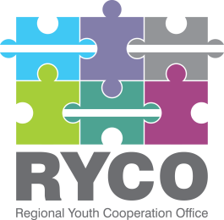

September 26st, 2023

ADDITIONAL INFORMATION

Contract title: “Production of online content for the project's activities of Regional Youth Cooperation Office (RYCO)”

Having regard to Section 5 of the “Instructions to tenderer”, part of the published tender dossier in the frame of the “Production of online content for the project's activities of Regional Youth Cooperation Office (RYCO)” call, in response to an inquiry submitted please find below the additional information provided:

Question no. 1 | Could you please confirm whether the existing version of the website was developed using WordPress?
Answer no. 1 | - Yes. The existing version of the Website was developed using WordPress.
Question no. 2 | Website Structure: We've noticed that the project includes several sections, namely "Info," "News," "RELHub," "Opportunities," and "Contact." We would appreciate it if you could clarify whether the subpage you envision will be designed as a single-page layout that incorporates all these sections, or if the plan is to have each of these sections as separate pages.
Answer no. 2 | - We have envisioned it to be designed as a single-page layout, but we are open to different suggestions during the process.
Question no. 3 | REL Hub: Within the "REL Hub" section, could you please provide more details on how you envision presenting experts and documents? Do you see this section featuring a searchable database, filters, or any specific functionality for users to access these resources effectively?
Answer no. 3 | It should be a searchable database. In this phase, we have not defined other specific functionalities.
Question no. 4 | Opportunities: We'd like to gain a clearer understanding of what the "Opportunities" section entails. Are you envisioning a separate page for each opportunity, each with its unique content, or is there a different approach you have in mind? Additionally, will there be a requirement for users to apply for specific opportunities
Answer no.4 | - We would like to share opportunities provided by third parties, so applying over this platform is not planned. It should be a simple blog post, with hyperlinks leading to other websites.
Question no.5 | Contact: In the "Contact" section, could you clarify whether this will simply include contact information (such as an address, phone number, and email) or if you would like to incorporate a specific contact form that users can fill out to reach out to your organization?
Answer no.5 | - Simple contact information.

Thank you!

